**Last** calls for Horizon 2020, first views for Horizon Europe

***Published:***

*18 December 2019*

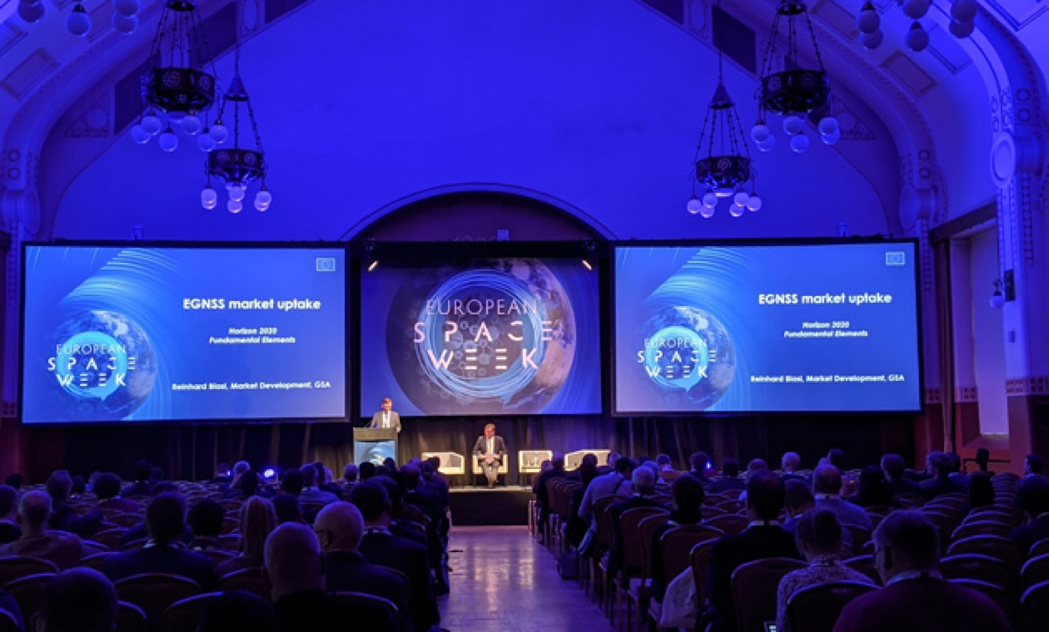

*Funding downstream R&I is an important part of the GSA’s strategy to foster EGNSS uptake and boost EU competitiveness*

**The second day of the EU Space Week event in Helsinki opened with an overview of the final tranche of project calls under the Horizon 2020 space programme. The final Horizon 2020 EGNSS (Galileo and EGNOS) calls are now open, with a closing date of 5 March 2020. The session covered research and innovation topics across Copernicus, EGNOS and Galileo programmes and also took a look to the future with Horizon Europe.**

The context of the calls, in terms of EGNSS market uptake, was described by Reinhard Blasi from the GSA. “European investments in EGNSS are already making profits, with some EUR 2.8 billion of benefits computed for 2018 alone,” he stated. Currently EGNSS market revenues represent 25% of global sales, with a target of 30% to be achieved by 2025.

Funding downstream research and innovation is an important component of the GSA’s integrated strategy to foster the adoption of EGNSS technologies and boost EU competitiveness.

The H2020-SPACE-EGNSS-2020 call is open until 5 March, has an overall indicative budget of EUR 21 million and covers four topics: EGNSS apps for green, smart transport, EGNSS for mass market digitisation, EGNSS apps for resilience and environmental protection, and EGNSS applications for public authority procurement of research. The last topic is the first attempt to use the Pre-Commercial Procurement (PCP) instrument under Horizon 2020 in the EGNSS domain.

**Fundamental work**

The GSA’s Fundamental Elements programme has also issued project calls with more to come. The published calls include development of an enhanced GNSS User terminal, emerging EGNSS receiver technologies, development of advanced interference systems, and the development of a drone-borne double frequency receiver. Three more calls to be published in December will cover receivers for rail applications, high precision in the mass market, and a shipborne double frequency, multi-constellation receiver.

**Read this:** [GSA funding: Filling the gaps and emerging technologies](https://www.gsa.europa.eu/newsroom/news/gsa-funding-filling-gaps-and-emerging-technologies)

“There is still much to do in 2020 and beyond,” said Blasi. “The GSA has three main objectives: to complete the uptake of EGNSS in more long-term regulated markets, position Galileo as the leader with its differentiating characteristics including authentication and high accuracy, and continue to support the downstream industry.”

Eric Guyader from the European Commission outlined upcoming calls administered through the Commission’s EGNSS Mission and Services (MAS) actions. Two calls are to be published soon on R&D for EGNOS services for payment or liability critical applications in the road sector and EGNSS rail safety services.

**And this:** [Targeting the development of a drone-borne Galileo receiver](https://www.gsa.europa.eu/newsroom/news/targeting-development-drone-borne-galileo-receiver)

In addition, up to eight calls may be published in 2020 under the European Space Agency administered Horizon 2020 Satellite Navigation programme (HSNAV) with some EUR 2 million earmarked for projects relating to EGNSS evolution projects.

**STRIKE success**

An EGNSS research success story was provided by Zahidul Bhuiyan of the Finnish National Land Survey who described the [Strike-3 project](http://www.gnss-strike3.eu/) funded under Horizon 2020 looking at standardisation of GNSS Interference Threat Monitoring and Receiver Testing. The project had set up an international network to monitor GNSS interference. “GNSS needs protection,” said Bhuiyan. “STRIKE-3 aimed to improve our understanding of the threat scene facing stakeholders in implementing GNSS safety and security.”

The project found that out of over half a million monitored interference events, both unintentional and malicious, only 5% had an impact on the receiver, with the vast majority not actually denying the use of GNSS. The project reinforced the recognition that improved interference detection and mitigation can help the robustness of PNT services, in particular for critical infrastructure, and its receiver testing standard document provides a good initial test standard to ensure that reports from different systems are compatible.

**Horizon Europe**

Although the budget for the next Framework R&D programme for 2021-2027, Horizon Europe, is still subject to negotiation Mats Ljungqvist of DG GROW gave an overview of the current state of play. The current budget for the EU Space Programme in Horizon Europe is EUR 16 billion with some EUR 9.7 billion allocated to EGNSS topics.

An orientation document on [the first strategic plan and work programme for Horizon Europe](https://ec.europa.eu/info/sites/info/files/research_and_innovation/strategy_on_research_and_innovation/documents/ec_rtd_he-orientations-towards-strategic-plan_102019.pdf)published at the end of October contains two sections on space research and innovation: 4.8 ‘A globally competitive space sector reinforcing EU sovereignty’ and 4.11 ‘New services from Space for the EU society and economy’.

Within the three pillars of Horizon Europe, Pillar 2 on Global Challenges and Industrial Competitiveness is allocated around half the total budget and includes a cluster (Digital, Industry & Space) that directly addresses space topics. “Pillar 3 on Open Innovation will also be of interest to the space sector,” said Ljungqvist. “An Enhanced European Innovation Council will provide accelerator and pathfinder grants to help bring bright ideas to market.”

Higher innovation funding should also be made available via an enhanced InvestEU programme where a European Union guarantee of some EUR 40 billion is looking to mobilise up to EUR 700 billion of private investment for growth and scale-up.

Together with a new Commission Directorate-General for Defence and Space, starting work at the beginning of 2020, there is a clear focus for space-related strategy and activities in Europe that reflect the growing importance of the space sector.

The GSA and the Commission have also been consulting with GNSS user communities to take their input into consideration when defining EGNSS downstream funding priorities in the new financial perspective. A [recent report](https://www.gsa.europa.eu/sites/default/files/uploads/european_gnss_downstream_research_innovation_priorities_and_consultation_results.pdf) from the GSA summarises the results of these consultations and outlines future R&I priorities.